****NAME:______________ Target: ____/40 or ____ % 👍 👎

**Year 7 HASSL**

**(Water in the World In-class Task)**

In-class Test - Task 4 (12.5%) /40

**Instructions: 45 minutes Working Time and 5 minutes Reading Time, Test conditions apply.**

**Section 1: Please circle the correct response. (11 marks)**

1. What form of precipitation is the most common in Australia?
2. Rain
3. Hail
4. Sleet
5. Snow
6. Which of the following is not a renewable resource?
7. Solar
8. Wind
9. Coal
10. Hydroelectricity
11. Evaporation, precipitation and condensation make up the _____________________.
12. ecosystem
13. lake effect
14. weather pattern
15. water cycle
16. The water cycle is driven by the:
17. moon
18. clouds
19. oceans
20. sun
21. When water evaporates directly from plants, it’s called:
22. condensation
23. sublimation
24. transpiration
25. precipitation
26. When water droplets become large enough to fall from the clouds, it’s called:
27. condensation
28. transpiration
29. sublimation
30. precipitation
31. During evaporation water goes from a _________________ to a ___________________.
32. solid, gas
33. liquid, gas
34. liquid, solid
35. liquid, plasma
36. Clouds form through the process called…
37. transpiration
38. infiltration
39. evaporation
40. condensation
41. When water is said to enter the ground, the process is known as
42. condensation
43. infiltration
44. transpiration
45. evapo-transpiration
46. The name given to freshwater running underground is called…
47. aquifers
48. creeks
49. streams
50. rivers
51. Which of the following foods has the greatest water footprint?
52. 1 kg of sugar
53. 1kg of chocolate
54. 1 kg of beef
55. 1 kg of olives

**Section 2: (10 marks)**

1. List four uses of water. (2 marks)

* ___________________________________________________________
* ___________________________________________________________
* ___________________________________________________________
* ___________________________________________________________

1. Explain one example of where water is misused. (2 marks)

________________________________________________________________

________________________________________________________________

________________________________________________________________

________________________________________________________________

1. Outline two examples of sustainable water strategies for the home. (4 marks)

* _____________________________________________________________

___________________________________________________________________

___________________________________________________________________

* _____________________________________________________________

___________________________________________________________________

___________________________________________________________________

1. Define the term ‘water footprint’. (2 marks)

________________________________________________________________

________________________________________________________________

________________________________________________________________

________________________________________________________________

1. Differentiate between direct and indirect water, in relation to the water footprint.

(3 marks)

________________________________________________________________

________________________________________________________________

________________________________________________________________

________________________________________________________________

________________________________________________________________

________________________________________________________________

________________________________________________________________

________________________________________________________________

________________________________________________________________

________________________________________________________________

1. Describe the role of water on Earth. Provide specific examples to help support your explanation. (4 marks)

________________________________________________________________

________________________________________________________________

________________________________________________________________

________________________________________________________________

________________________________________________________________

________________________________________________________________

________________________________________________________________

________________________________________________________________

________________________________________________________________

________________________________________________________________

________________________________________________________________

________________________________________________________________

________________________________________________________________

________________________________________________________________

1. Label the diagram of the water cycle with following processes. (5 marks)

• Evaporation

• Transpiration

• Condensation

• Precipitation

• Surface Run Off

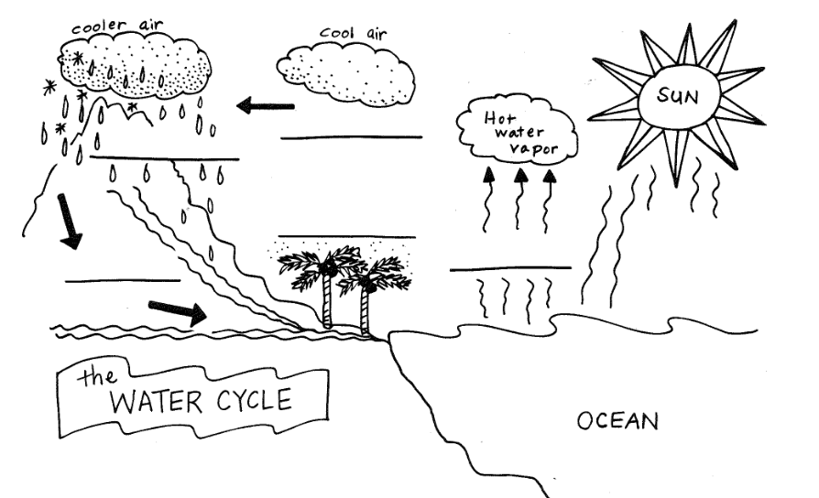

1. With reference to the diagram above, describe the movement of the water cycle between land and the ocean. (5 marks)

________________________________________________________________

________________________________________________________________

________________________________________________________________

________________________________________________________________

________________________________________________________________

________________________________________________________________

________________________________________________________________

________________________________________________________________

________________________________________________________________

________________________________________________________________

________________________________________________________________

________________________________________________________________

________________________________________________________________

________________________________________________________________

________________________________________________________________

________________________________________________________________

________________________________________________________________

End of test paper!